
Waitemata Rowing Club Inc.
Taipari Strand, Te Atatu Peninsula PO Box 79 017, Royal Heights, Auckland
www.waitematarowing.org.nz waitematarowingclub@gmail.com

Here is some basic information on how the club works and what you can expect as a member of Waitemata Rowing Club

Waitemata Rowing Club is run 100% on the efforts of volunteers, being a member means that you are expected to help at the club, be it with away events, fundraising or maintenance and open days at the club rooms.

Training Times

We would expect all rowers to attend at least 3-4 training sessions per week, so you don’t let your fellow crew members down.

The club is open for training –
- from 4-6PM on Monday, Wednesday, and Friday
- from 7:30-9:30AM on Saturday and Sunday

These training times are all year round and become more flexible when approaching school holidays, winter daylight times, important regattas or training milestones. In addition, there will also be gym circuit training and fitness (juniors do not row in bad water or weather conditions).

Clothing & Equipment [some guidelines – from ‘head-to-toe’]

It may seem a minor and unimportant issue but being correctly dressed for your sport can save a great deal of time and prevent missed sessions through injury and illness.

Headwear: A lot of body heat can be lost through the head so wearing a hat is important when it is cold, a thin hat is better as it is less likely to cause you to overheat whilst you train. People with hair long enough to cause distraction (need to rearrange it whilst rowing) should tie, pin or restrain it under a cap. When the sun is out a cap or sun hat is vital.

Upper body: The important issues to think about here are practicality and keeping at a comfortable temperature. Both these issues can be dealt with by wearing many thin layers, preferably tight fitting. The reason for this is that close-fitting layers will not obstruct your hands around the finish of the stroke (as a Hoodie or Sweater will).
Layers can also be taken off as you warm up rather than having only the two options that a T-shirt and jumper combination offers. Always tuck tops in, as oil on the boats and ergs will ruin clothes getting stuck in runners during training or racing and slow you down! When the sun is out keep covered with a light-colored sleeved top, remember the water intensifies the effect of the sun on your skin. We may run in the winter for training in the evening. For these sessions always try to wear a white layer on top or even a ‘high viz vest’ if you have one.

Hands: These should be jewelry free; rings create and encourage blisters. Gloves should be avoided as they decrease your control over the handle.

Legs: Tracksuit bottoms should never drag on the ground. As with the upper body the layers principle applies. Leggings will keep you warm throughout the winter and you will never catch your fingers on them when 'tapping down', used when taking oars from the water at the end of a stroke.
Note. Modern tight-fitting sport specific clothing dries very quickly lessening the likelihood of catching a chill from a rain soaked or sweaty cotton top.

Footwear: Everyone without exception must wear trainers designed for sports (running or cross-training preferably). They should also be done up so that the foot is fully supported. All rowers must wear socks in the boats, and many find ‘slides’ type sandals useful.
Coxes: Always wrap up in many layers, you can always peel them off. Be aware that during the winter the difference in temperature between shade and sun can be very great. Always be prepared for rain.

Accessories: Sunglasses – If you find the sun distracting or it gives you a headache then wear sunglasses (Surprisingly relevant throughout the winter when the sun is low in the sky).
Scarves – NO! (except for coxes)

Some of the ideas raised here may seem odd (boys in tights) but next time you are at a regatta look at the good athletes. Almost all of them will be wearing clothes as described here. They may look silly initially but in deepest winter or on the hottest June day the priority is staying at the right temperature and ensuring your dress is not going to hinder your rowing.

ALWAYS BRING ALONG A DRY CHANGE OF CLOTHES, A TOWEL, AND WATER.

Coaching
The coaching team impart the technical knowledge and skills crucial to boat speed and crew development. They put together the on-water and off-water training programs for rowers to be both fit and technically competent. The coaches do their best to provide a safe, supportive environment that will motivate each participant to reach their goals.

Regattas

During the season, rowers will attend many competitive regattas usually starting in November at Lake Pupuke and continuing through to approximately mid-February. At that stage, Club regattas are finished, and School rowing takes over, starting with Head of the Harbour in February, & culminating with the North Island Secondary Schools Championship Regatta and New Zealand Secondary School Championship (Maadi Cup) held in March.
Regattas are a time to see how all the hard work is shaping up or what can be done better. Rowers will need to arrive at a regatta ready to do their best.
There are no half-hearted attempts at regattas, as this can let both themselves and their crewmates down.

WRC attends regatta all over New Zealand, with the majority held at either Lake Pupuke on the North Shore, or at Lake Karapiro, just past Cambridge.

Parents are encouraged to attend the regattas and support their children. Things to bring to regattas as a supporter are camp chairs, or something to sit on, binoculars, lunch and snacks for the day. An activity or reading material is always good to have on hand as there can be lengthy down times between races. Be aware that regattas often don’t run to time due to
weather. Layers of Clothing are also a great idea. WRC supporters usually sit together at Regattas – it’s a great way to meet fellow parents and provide support to each other.
Parents are expected to transport their child to and from regattas or arrange/offer car- pooling amongst themselves.

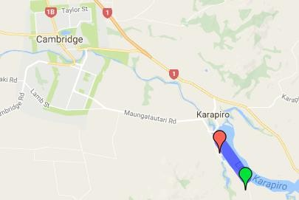
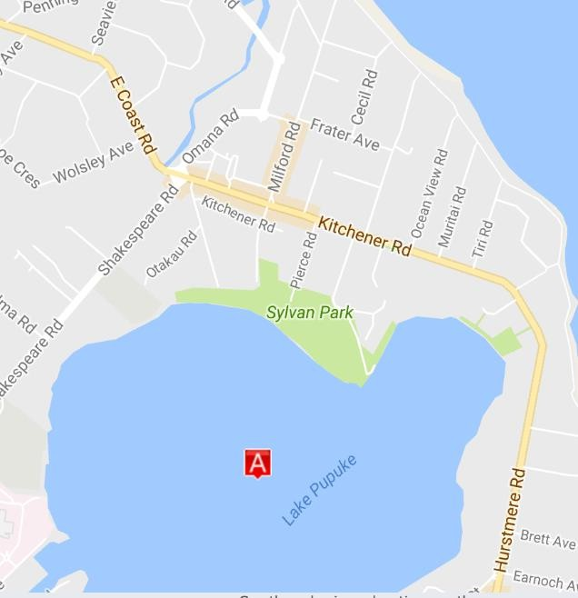
Lake Pupuke, Takapuna Lake Karapiro, Cambridge

Guidelines for Parents

Rowing is a sport which by nature relies on the active involvement of parents. We need your support to help your child and their crew to train and compete to the best of their ability.
Please take the following into consideration:
- Waitemata Rowing Club is a volunteer run organization and relies on the participation of all members. Families will often be contacted throughout the year to volunteer time whether this be help with fundraising, transport or supervision
and off water logistics support at regattas. Participation in these
activities help to further the success of each rower or coxswain’s hard work on the
water
- Encourage your child’s self-discipline and independence as much as possible. They will learn faster from their own mistakes. Remember that there are often more learnings that come from losing rather than winning.
- Rowing is a physically and emotionally demanding sport. There is a lot of on water pressure on the rowers so please try to minimize the pressure off water. While
everybody’s goal is to win; there are a lot of top schools and clubs that run very
professional programs. Winning at a national level requires total dedication, hard work, good management and some good fortune.
- Parents volunteers are required at both training camps and regattas. WRC generally camps in tents at regattas, and we require help with cooking and general
- camp/regatta duties.
- Rowers are expected to bring to Regatta’s their own named plates, cutlery, tea
towels, bedding, towels. And most importantly, home baking to contribute!
- Costs
  - Once your child has ‘signed up’ to join WRC, you will be issued an invoice for between $500-900. This covers one calendar year and is the full membership cost. This can (by arrangement) be paid off in installments.
  - Summer Training Camp. Every year between 26 December to 3rd January.
Please see notes about Camp. Costs are approx. $250 per rower
  - Winter Camp. Approx. $200 per rower
  - ‘Away’ Regattas. Approx. $25 / person / night
  - WRC Rowsuit for racing in regattas approx. $135
  - WRC branded clothing available upon request

Health and safety

The safety of our rowers whether on water or off water is of the upmost importance to us. The following outlines some safety points that the rowers themselves can individually manage to help ensure their own safety whether at training or at regattas. The latest copy of the Risk Management plan can be found on the Waitemata Rowing Club Web site.

Preparation
Have water with you at all times.
Do not share water bottles
Wash your hands or use hand sanitizer frequently Shower as soon as possible after training sessions
Clean out gym bags daily
Ensure rowing gear is washed after each use
Keep cuts, scrapes and blisters clean and bandaged when on water Keep sugary snacks or juice on you for after extensive training sessions
If you begin to feel unwell or injury yourself at training, you MUST let your coach know

Rowing Conditions
Conditions on water can change rapidly and often without much warning during a session on the water or at a regatta. Rowers must anticipate for these changes and come prepared to training and regattas. Rowers will practice/train in the majority of weather conditions (within reason) wind, rain, high temperatures, low temperatures). In extreme cases training
will either take place on indoor rowing machines or if necessary will be cancelled. We will never row in conditions that are unsafe. This includes heavy fog, high winds or lightning storms.

Blisters
Unfortunately, blisters are inevitable in rowing but particularly at camp.

You can minimize the effect they have on your performance by applying tape to your hands. Use Elastoplast and Nextcare brands as they stick well and come off cleanly. You will need both 1” and 2” and will go through several rolls in a season. There is an art to applying the tape, so it is protective, but allows you to function well, and doesn’t roll up while you are rowing:
Always cut the tape with scissors – the raw edges can roll up if you tear the tape
Always tape your hands 20 minutes BEFORE rowing so it has time to bind strongly to your skin
When taping your palm, it can be a good idea to cover the tape with a glove or with electrical tape to give additional protection from rolling up.

Hydration
Drink plenty of fluids, don’t wait until you feel thirsty, this is a poor indicator of fluid needs. Although water is the preferred replacement fluid, sports drinks (containing 4%-8% carbohydrates and small amounts of electrolytes) provide additional energy from carbs which can prevent fatigue and enhance performance, especially during prolonged events. It also provides salts which aids the rehydration process
Flavored drinks i.e. sports drinks and cordial may encourage fluid consumption more than plain water
Cool fluids may be absorbed more rapidly than warm fluids.

